Skin User Guide

1. How to use this skin?
Thank you for choosing Flat skin pack.
Before you upload the skin to your site, you must unzip the downloaded file.
You will find 2 folders:
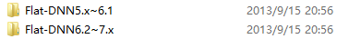
a. Flat-Skin-DNN5~6.1. these skins can be used in DNN 5~6.1.
b. Flat-Skin-DNN6.2~7, these skins can be used in DNN 6.2+ and DNN 7, including a social layout for building social networks in DNN 6.2+.
Important Note: When you use this skin in DNN 5. Please Install "DDRMenu_02.00.01_DNN5.5.0_NET3.5_Install" at first, or else the menu will disappear. You can find the file in "UnzipMe_Other Files.zip" file.

2. How to install DNN 5 skins?
You can follow these steps:
a. Login your site
b. Go to Host/Extensions
c. Click "Install Extension Wizard"
d. Click on browse and select the INDIVIDUAL COLOR Skin ZIP file
e. Ignore the File Restrictions, and the Click Next, Next, Next.
f. Return
g. Click "Admin/Skins ". You will find the skin in the drop-down list of "Skins".

3. How to install DNN 6 skins?
You can follow these steps:
a. Login your site
b. Go to Host/Extensions
c. Hover over "Manage" button.
d. Click "Install Extension Wizard"
e. Click on browse and select the INDIVIDUAL COLOR Skin ZIP file
f. Ignore the File Restrictions, and the Click Next, Next, Next.
g. Return
h. Click "Admin/Skins ". You will find the skin in the drop-down list of "Skins".

4. How to install DNN 7 skins?
You can follow these steps:
a. Login your site
b. Go to Host/Extensions
c. Click "Install Extension Wizard"
d. Click on browse and select the INDIVIDUAL COLOR Skin ZIP file
e. Ignore the File Restrictions, and the Click Next, Next, Next.
f. Return
g. Click "Admin/Skins ". You will find the skin in the drop-down list of "Skins".

5. How to add the slider banners?
The skin includes 4 slider JS plugins, we provided 12 banner templates for you. You can find these templates in "Layerslider Templates" and “Other Sliders Templates” folder. Then, You can follow these steps:
a. Add a HTML module to BannerPane.
b. Choose "Banner" Container as this module container.
c. Paste the template codes into the HTML module (Choose "HTML" mode in HTML Editor, not "Design" mode).
d. Edit the template.

- Layer Slider
When you add the Layer slider templates codes to HTML editor, please choose "Basic Text Box" and "Html" render mode. Or else, the editor will remove all effect settings in style.
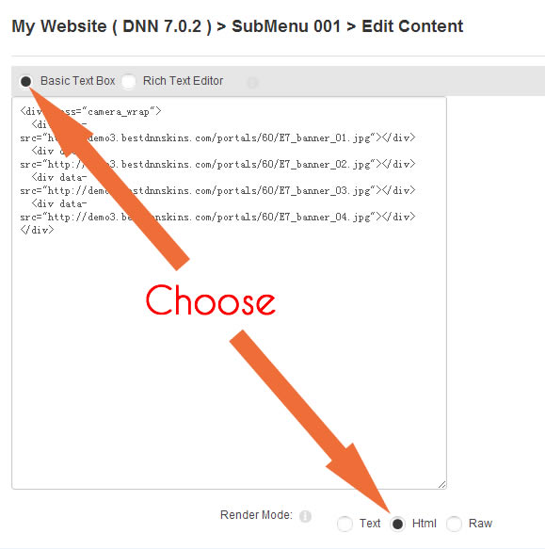
If you want to create a custom slider based on layer silder, we suggest that you edit the codes on our template html pages in "Layerslider Templates" , then you can see the effect directly after you save the codes. After you finish the custom slider, you can copy the template codes to DNN HTML Editor. If you need more informations about the 2D/3D silder, please see the "Layerslider Original File.zip" in "UnzipMe_Other Files.zip"

2) Flex Slider
We provide two different class name for two slide effects:
class="flexslider" ---- Slide Effect
class="flexslider2" ---- Fade Effect
You can choose one class name for your custom slider.
We also provide two positions for the caption:
class="flex-caption" ---- Caption on left
class="flex-caption2" ---- Caption on right
If you want to change some css settings about the slider, please open flexslider.css file in css folder and edit the css settings there.
If you want to change the slide speed, please open custom.js file in js folder and edit the js settings:
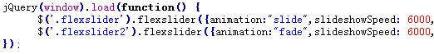
If you need more informations about the FlexSlider, please see the "FlexSlider Original File.zip" in "UnzipMe_Other Files.zip".

3) Trans-banner Slider
If you want to reset the size of the slider, you can open trans-banner.css in skin/css folder and find these codes:
.TB_Wrapper {
position: relative;
background: #EEEEEE url(../images/TB-preloader.gif) center center no-repeat;
max-width: 1600px;
height: 530px;
cursor:e-resize;
margin: 0 auto;
}
Please reset the settings the same as the size of your banner.
If you want to reset the js settings for the slide banner. Please open custom.js in skin / js folder and see here:
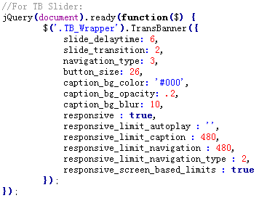
You can reset the slide_delaytime:6 to change the the delay time of each banner.
We also attach the original files of the slider plugin in UnzipMe_Other-Files.zip. You can see more detailed Instruction and examples about the sliders and learn to customize the sliders.
Note: The slider requires a jQuery above 1.7.1 version. If your jQuery version is lower, please upgrade it, you can see the jQuery version in Host >> Host Settings >> Advanced Settings tab >> jQuery Settings.

4) Unoslider
If you use the Unoslider templates and want to customize some settings of the banners, Please open custom.js in skin / js folder and see here:
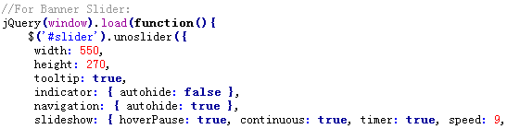
You can change the width and height of the slider, also can reset the speed of slider, the value is bigger, the speed is lower.

6. How to use the custom panel on the left of page?
When you click the gear button on the left of page, the custom panel will slide out.
You can choose background colors, patterns and skin width options.
Your choose will be saved in the Browser Cookie. You can click "Reset" button to return all default values.
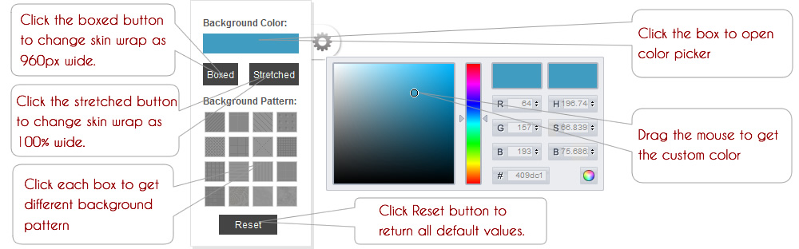

The custom panel can be used by all visitors. Although all visitors can adjust the colors and patterns by the custom panel, all the custom value will be saved in vistors' browser cookie. The skin color still is the pre-defined color for the other visitors. The website administrator can't use the custom panel tool to set a permanent color for all visitor, but can set the pre-defined color by editing css settings.

7. How to close the custom panel on the left of page?
You can close the custom panel easily. Please open all.css in each skin/css folder and find these codes:
#custom-button {display:block;position: fixed;...}
#custom_wrapper{ display:block;position: fixed;...}
Change as:
#custom-button {display:none;position: fixed;...}
#custom_wrapper{ display:none;position: fixed;...}

8. How to set the skin width as boxed, a custom color scheme and background image permanently?
1. Set the skin width as Boxed:
You can open all.css in each skin/css folder.
Change:
.skin_wrapper { width:100%; ... }
To:
.skin_wrapper { width:1140px; ... }

2. Set a custom color permanently.
E.g. Flat-CadetBlue skin, open all.css and find the following codes:
.pre_defined_color { background:#54ADB4;}
You can change all #54ADB4 settings in all.css, skin.css and container.css (the file in corresponding container folder) to your custom color.

3. Set a custom background for the page body.
Open skin.css and find
#Body{ background: url(images/bg_pattern/bg_grid_01.png) #fff fixed;color:#555; }
You can select one pattern in images/bg_pattern folder or use your own background image. You can also upload a background image on the site directly, just set the body background in Admin >> Site Settings.

9. How to create Hover Icon Effect?
We provide the Hover Icon Effect template in "Content Templates" folder. You can follow these steps:
- Add a HTML module.
- Choose "Notitle" Container as this module container.
c. Paste the "Icon Effect template" template codes into the HTML module.
d. Edit the template.
If you want to modify the settings, please open all.css file and find the codes under /*Demo Top Bubble Style*/
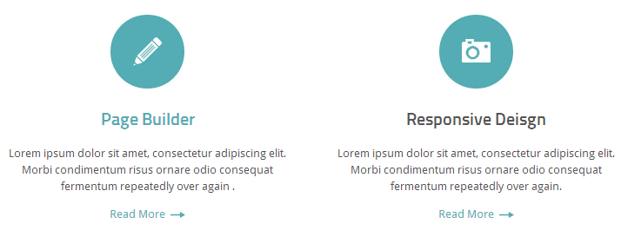

10. How to add Carousel Slider effect?
We provide the carousel template in "Content Templates" folder. You can follow these steps:
- Add a Text/HTML module.
b. Paste the "Carousel" template codes into the Text/HTML module.
c. Edit the template.
You can also create your custom carousel based on "Carousel Basic". If you want to modify the settings, please open all.css file and find the codes under
/*--------- CarouFredSel Style ----------*/
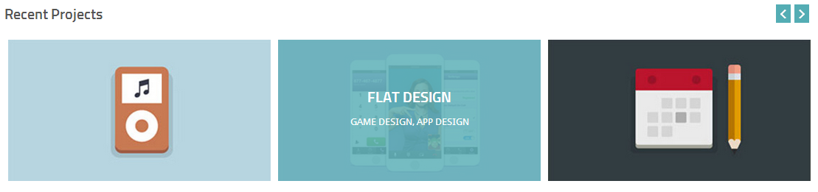

11. How to create Hover Image Magnify Effect?
We provide the Hover Image Magnify template in "Content Templates" folder. You can follow these steps:
- Add a HTML module.
- Choose "Notitle" Container as this module container.
c. Paste the "Hover Image Magnify" template codes into the HTML module.
d. Edit the template.
If you want to modify the settings, please open all.css file and find the codes under /*-------------Magnify Img Style-----------------*/
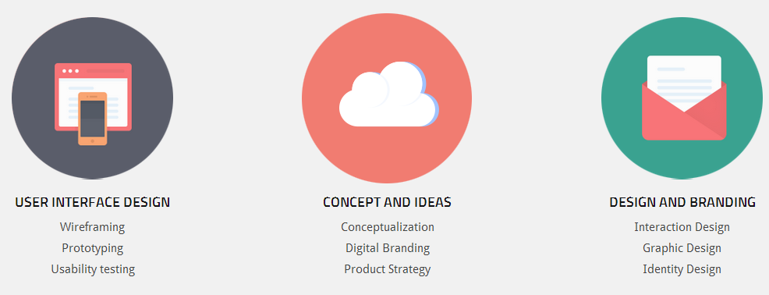

12. How to create Vertical Tabs effect?
We provide the Tabs-Vertical template in "Content Templates". You can follow these steps:
a. Add a Text/HTML module.
b. Paste the "Tabs-Vertical" template codes into the Text/HTML module.
c. Edit the template.
You can also create your custom vertical slider based on "Tabs-Vertical Basic". You can find the css settings codes in all.css file under:
/*--------- Togglable Tabs Style ----------*/

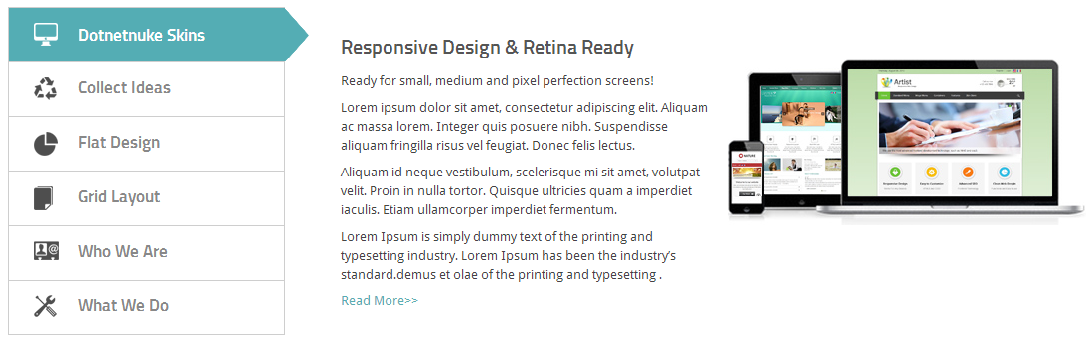

13. How to create Accordion Effect?
We provide the Accordion template in "Content Templates" folder. You can follow these steps:
a. Add a Text/HTML module.
b. Paste the "Accordion" template codes into the Text/HTML module.
c. Edit the template.
You can also create your custom accordion based on "Accordion Basic". If you want to modify the settings, please open all.css file and customize the codes under /*Accordion Style*/
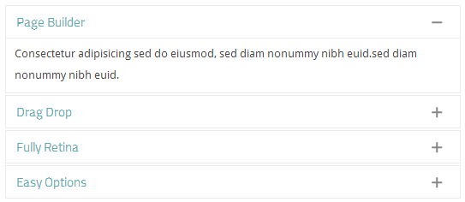

14. How to create Pictures Lightbox effect?
We provide the lightbox template in "Content Templates" folder. You can follow these steps:
a. Add a HTML module.
b. Paste the "Lightbox" template codes into the HTML module.
c. Edit the template.
The basic frame:
<a href="../xxx.jpg" title="xxx" class="fancybox" rel="group"><img alt="" src="../xxx-s.jpg" /></a>
Please add the big picture path in href="xxx.jpg", add the thumbnail path in <img alt="" src="../xxx-s.jpg" />.
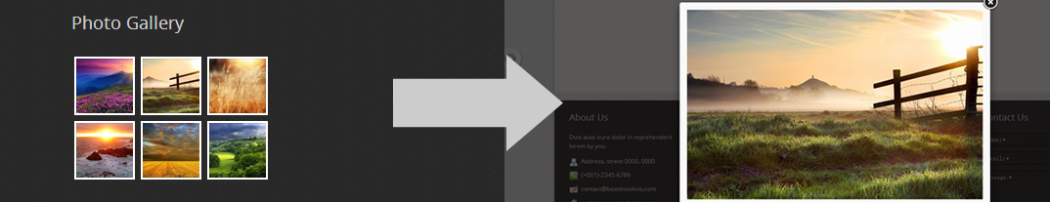

15. How to create pictures shake effect ?
We provide the shake template in "Content Templates" folder. You can follow these steps:
a. Add a HTML module.
b. Paste the "Image Shake" template codes into the HTML module.
c. Edit the template.
The basic frame:
<div class="shake"><img alt="" src="../..." /></div>
You can add class="shake" to div or span and if the child layer have img tag, the image will shake when the mouse hover over it.

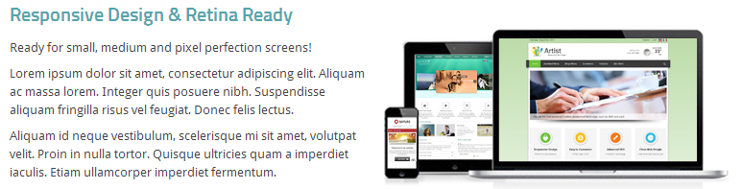

16. How to create Testimonials Effect?
We provide the Testimonials template in "Content Templates" folder. You can follow these steps:
a. Add a Text/HTML module.
b. Paste the "Testimonials" template codes into the Text/HTML module.
c. Edit the template.
If you want to modify the settings, please open all.css file and customize the codes under /*Quovolve Style*/
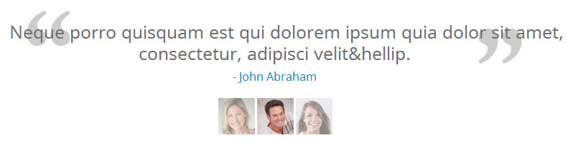

17. How to add Social Media Icons on your site?
The skin includes three groups of major social media icons. You see the demo page: http://demo.bestdnnskins.com/Flat/Features/Shortcodes/SocialIcons/
You can find the "Social Icons" template in "Content Templates" folder. Follow these steps to add them:
a. Add a HTML module.
b. Paste the "Social Icons" template codes into the HTML module.
c. Edit the template.
All social icons settings are set in skin.css. Under /* Social-Links */ .. /* Social-Links2 */.. /* Social-Links3 */
Please choose some css names which you need and add them into the templates.
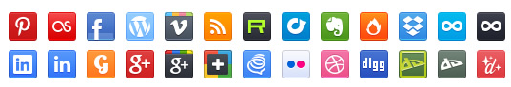

18. How to add an icon for the menu item?
Please go to Page Settings >> Advanced Settings >> Icon, you can upload an icon and choose it, then update page. You will see the menu icon.

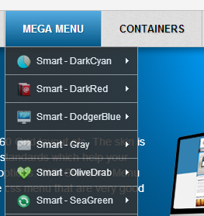

19. How to import the template like our demo page?
We provide "Flat-Skin-Home.page.template" in "Content Templates" folder. Follow these:
1. Install "Flat-CadetBlue" skin at first.
2. Login FTP and Upload all demo images ( in UnzipMe_DemoSites Files.zip) to ../Portals/0/.
3. Upload the template file to ../Portals/0/Templates.
4. Click Pages >> Import on your site, choose the template “Flat-Skin-Home” and create a page or replace the current page.

20. How to build a site like our demo site?
We provide the demo site template for DNN 7.1+ (Only can be used for DNN version 7.1+ ). All template files are in “UnzipMe_DemoSites Files.zip” . You can follow these steps to build a sit like our demo site.
1. Unzip the file “UnzipMe_DemoSites Files.zip”
2. Login FTP and Upload three folders “F15-StandardMenu”, “F15-MegaMenu” and “F15-Layouts” to ../Portals/_default/Skins .
3. Upload one folder “F15-Containers” to ../Portals/_default/Containers .
4. Upload the template files: Flat Skin Demo Site.template, Flat Skin Demo Site.template.resources to ../Portals/_default
5. When you build a new site in Host >> Site Management, you can choose the template: Flat Skin Demo Site, then you will get the site the same as our demo site.

21. How to get the LeftMenu Page?
When you use the LeftSidebar layout skin for a page and the page is a level2 page or the page is the parent page of level2 page, then LeftMenu will appear.

22. How to upload your own logo?
Please go to Admin >> Site Settings >> Appearance >> Logo. You can upload an image there and set it as logo.

23. How to use the Social Layout on DNN 6.2?
We provide the layout sketchs in "Social-Page Sketches" folder. When you are using DNN 6.2, please refer to them and move the social modules to corresponding panes.

24. How to use 404 layout on DNN 7.1?
From DNN 7.1, all portals include a 404 Page. You can login DNN site and go to Admin >> Page Management, then see the left list of pages. The last one is 404 error page.
1) You can click it and change the page skin in Appearance.
2) You can right click the page name, click “View Page” in the dropdown list, go the page.
3) In 404 page, you can write any custom content there.
For more details about 404 page, you can see: http://www.dnnsoftware.com/wiki/Page/DNN-404-Handling

25. How to use the Typography options and JavaScript plugins from Twitter Bootstrap?
We have offered the demo use for Typography options and JavaScript plugins on our demo site, please see:
Alerts: http://demo.bestdnnskins.com/Flat/Features/Shortcodes/Alerts
Buttons: http://demo.bestdnnskins.com/Flat/Features/Shortcodes/Buttons
Collapse: http://demo.bestdnnskins.com/Flat/Features/Shortcodes/Collapse
Dropdowns: http://demo.bestdnnskins.com/Flat/Features/Shortcodes/Dropdowns
FontIcon: http://demo.bestdnnskins.com/flat/Features/Shortcodes/FontIcon
Images: http://demo.bestdnnskins.com/Flat/Features/Shortcodes/Images
Icons: http://demo.bestdnnskins.com/Flat/Features/Shortcodes/Icons
Info boxes: http://demo.bestdnnskins.com/Flat/Features/Shortcodes/Infoboxes
Modals: http://demo.bestdnnskins.com/Flat/Features/Shortcodes/Modals
Progress bar: http://demo.bestdnnskins.com/Flat/Features/Shortcodes/Progressbar
Popovers: http://demo.bestdnnskins.com/Flat/Features/Shortcodes/Popovers
Social Icons: http://demo.bestdnnskins.com/Flat/Features/Shortcodes/SocialIcons
Tool tips: http://demo.bestdnnskins.com/Flat/Features/Shortcodes/Tooltips
Tabs: http://demo.bestdnnskins.com/Flat/Features/Shortcodes/TogglableTabs

You can go to http://twitter.github.com/bootstrap learn more about Bootstrap.
The skin imports most components in Bootstrap except "Forms", because "Forms" styles from Bootstrap conflict with DNN default form styles.

26. How to make the image retina ready?
You have two ways to make the image retina ready.
- Create two images: normal image and @2x image. Set the normal image as background in all.css or mobile.css and add the @2x image in bottom of mobile.css /*Retina Styles*/. You can refer to what we do for mobile_menu img, .mobile_search img etc.
- Create two images: normal image and @2x image. Refer to the "Retina Image Ready" template in "Content Templates". We have inserted a jQuery Plugin from http://dahliacreative.com/retinisejs/. You can read the guide there.
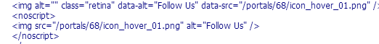

27. Some CSS styles instruction?
1) Google Fonts
By default the heading use “Titillium Web” and the body text use "Droid Sans", but if you want to use another google font you can edit these codes in skin.css:
@import url(http://fonts.googleapis.com/css?family=Droid+Sans);
@import url(http://fonts.googleapis.com/css?family=Titillium+Web:400,600,700);
You can also use CSS3 font-face to import a new font: http://www.w3schools.com/css3/css3_fonts.asp

2) Content font
It’s 'Droid Sans',Arial, sans-serif; by default, but if you want to use another font you can open skin.css file and reset the font-family settings.

3) Headings Settings
If you want to reset it, please open skin.css file and find the following codes:
h1{font-size:28px;line-height:1.5em;letter-spacing:0;color:#54ADB4;font-weight:600;font-family:'Titillium Web',Arial, Tahoma, sans-serif;}
h2{font-size:24px;line-height:1.5em;letter-spacing:0;color:#54ADB4;font-weight:600;font-family:'Titillium Web',Arial, Tahoma, sans-serif;}
h3{font-size:20px;line-height:1.5em;letter-spacing:0;color:#54ADB4;font-weight:600;font-family:'Titillium Web',Arial, Tahoma, sans-serif;}
h4{font-size:18px;line-height:1.5em;letter-spacing:0;color:#54ADB4;font-weight:600;font-family:'Titillium Web',Arial, Tahoma, sans-serif;}
h5{font-size:16px;line-height:1.5em;letter-spacing:0;color:#54ADB4;font-weight:600;font-family:'Titillium Web',Arial, Tahoma, sans-serif;}
h6{font-size:14px;line-height:1.5em;letter-spacing:0;color:#54ADB4;font-weight:600;font-family:'Titillium Web',Arial, Tahoma, sans-serif;}
h1 span, h2 span, h3 span, h4 span, h5 span, h6 span {font-family:'Titillium Web',Arial, Tahoma, sans-serif;}

4) Spacer Settings
We have set different spacer settings in skin.css. CSS codes as follows:
.pe-spacer.size10 { height: 10px;}
.pe-spacer.size20 { height: 20px;}
.pe-spacer.size30 { height: 30px;}
.pe-spacer.size40 { height: 40px;}
.pe-spacer.size50 { height: 50px;}
.pe-spacer.size60 { height: 60px;}
.pe-spacer.size70 { height: 70px;}
.pe-spacer.size80 { height: 80px;}
.pe-spacer.size90 { height: 90px;}
.pe-spacer.size100 { height: 100px;}
You can get different spacer by the following html codes:
<div class="pe-spacer size10"></div> <!-- 10px spacer -->
<div class="pe-spacer size20"></div> <!-- 20px spacer -->
<div class="pe-spacer size30"></div> <!-- 30px spacer -->

5) Border Settings
We have set different border settings in skin.css. CSS codes as follows:
.left_border{ border-left:1px solid #e9e9e9;}
.right_border{ border-right:1px solid #e9e9e9;}
.top_border{ border-top:1px solid #e9e9e9;}
.bottom_border{ border-bottom:1px solid #e9e9e9;}
You can get different border by the following html codes:
<div class="left_border"></div> <!-- left border -->
<div class="right_border"></div> <!-- right border -->
<div class="top_border"></div> <!-- top border -->
<div class="bottom_border"></div> <!-- bottom border -->

6) PC display and mobile display
We provide two css settings in all.css and mobile.css for PC display and mobile display.
.pc_display { display:block;}
.mobile_display { display:none;}
If you want a div/tag display on PC, but not mobile, please add css name pc_display.
If you want a div/tag display on mobile, but not PC, please add css name mobile_display.

7) Color Text and Color Background
We provide two css name settings in skin.css file:
.color_text { color:#54ADB4; }
.color_bg{ background:#54ADB4; }
You can add the css name to a div/tag to get the same color as the skin color scheme.

8) content fadein effect
If you like content fadein effect like the bottom area on our demo page. You can simply add class="inview p-hidden" . Just like this:
<div class="inview p-hidden">
Lorem ipsum dolor sit amet....
</div>

If you have any questions about the skin, please let us know.
E-mail: contact@bestdnnskins.com

